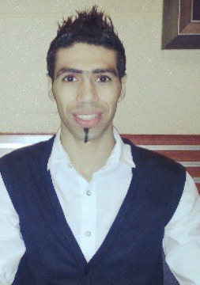

**Sadiq Mohammad Altaweel**

**Bachelor Degree in Banking & Finance**

**Personal Summary**

A highly motivated, ambitious and responsible Banking & Finance graduate with 4 years' experience in different fields. Can speak English , beside Arabic .

Has a polite, friendly, flexible personality and a very good communication skill.

**Personal Information**

**Nationality**: Bahraini

**Date of Birth**: 24-11-1986

**Age:** 33

**Place of live**: Bahrain

**Telephone**: 39650905

**Email**: **sadiq.altaweel@hotmail.com**

**Qualification:**

* **(2006 – 2013)-Bachelor Degree in Banking & Finance**

**Gulf University**

* **(24-Jan – 26 Jan 2010) – First Aid Training for Cabin Crew**

**Academy of Technical Training (GCAA)**

**(19 Feb 2009) –Initial Flight Attendant Course**

**Sama Airlines**

**( 2001-2004)- Secondary Cerificate**

**Noaim Boys School**

* **(27 Jan 2010)-Abinitio Aviation Security Course-**

**Emirates Group Security (Sama Airlines)**

**(28 Jan 2009) –Dangerous Goods Awareness Course – Sama Airlines**

**Experience:**

* **(February 2015-February 2016) : Sales Associate –F&F –AL futtaim Group (seef Mall).(one year)**
* **( 2007-2010) :Flight Attendant –Sama Airlines (3 years)**

**Personal Skills:**

* Friendly
* Flexible personality
* Able to work under pressure.